

***LAB REPORT 6***

***Muhammad Rafay***

***20P-0018***

***Computer Networks***

***Sec A***

**TASK 1**

**Topology**

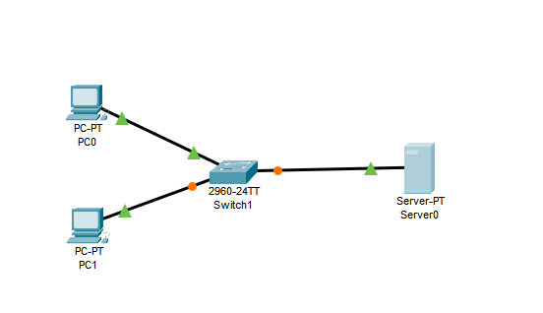

**Dns_server IP Config**

IP = 192.168.1.2

Subnet mask = 255.255.255.0

Default Gateway = 192.168.1.1

DNS server = 192.168.1.2

**PC0 Config.**

IP = 192.168.1.3

Subnet mask = 255.255.255.0

Default Gateway = 192.168.1.1

DNS server = 192.168.1.2

**PC1 Config.**

IP = 192.168.1.4

Subnet mask = 255.255.255.0

Default Gateway = 192.168.1.1

DNS server = 192.168.1.2

**DNS Server**Configuring to Record PCs

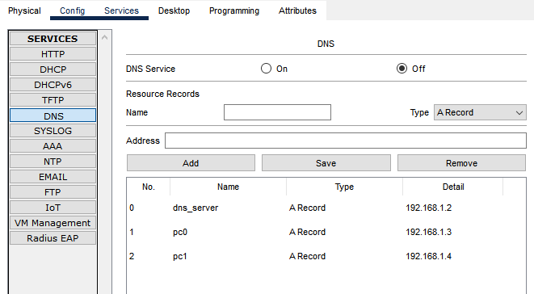

**Result.**

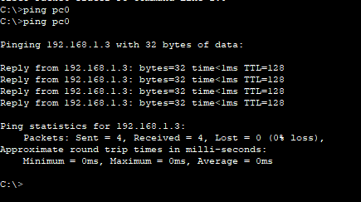

**LAB TASK. (Experiment 2)**

**Topology**

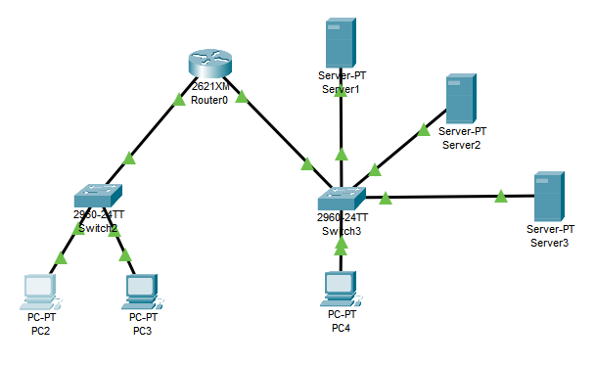

**Server1 (DHCP Server)**

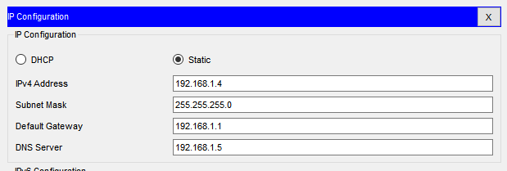

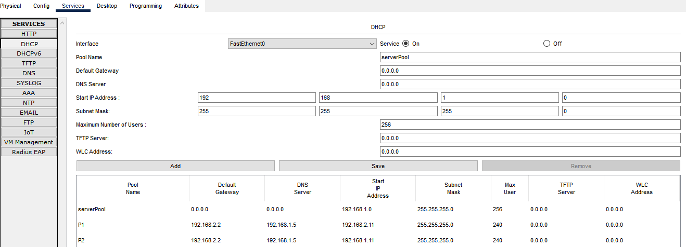

**Server 2 (Dns_Server)**

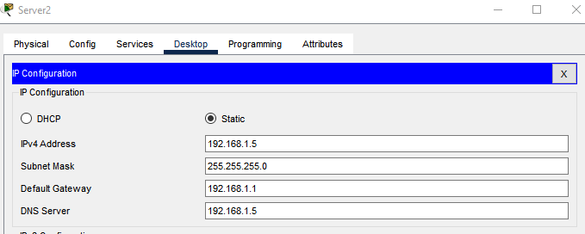

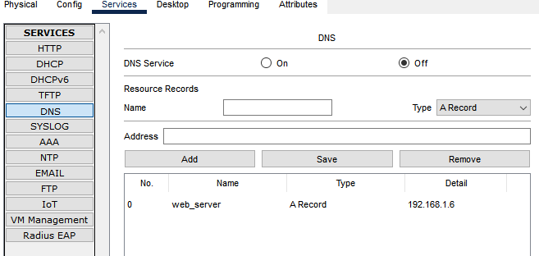

**Server3 (Web Server)**

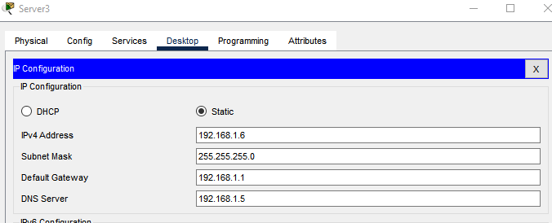

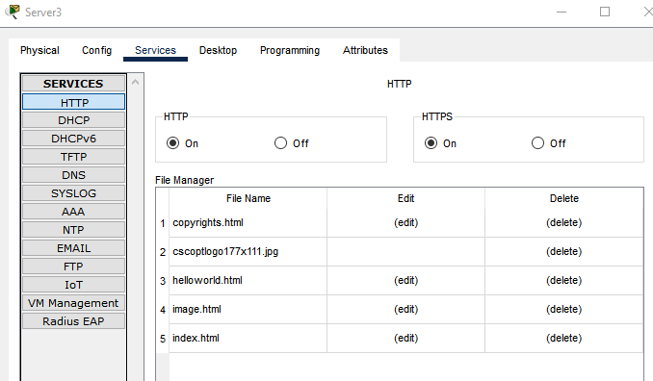

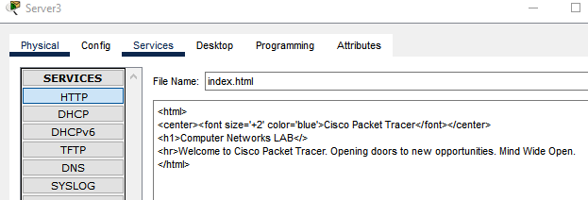

**Configuring Router Now & add ip using DHCP**

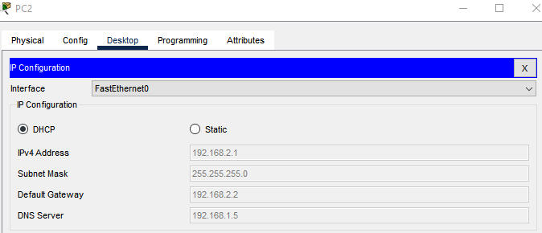

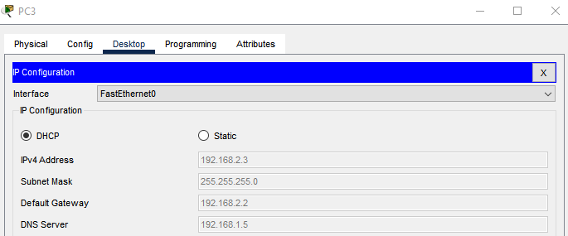

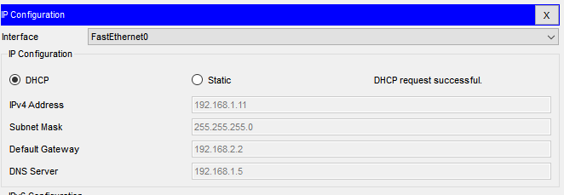

**WEB BROWSER.**

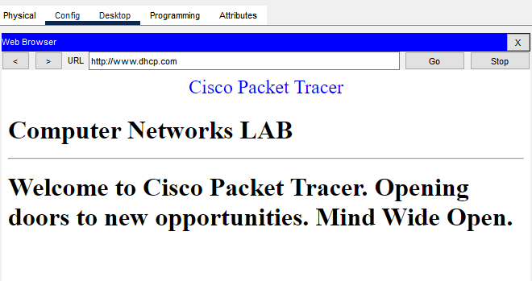

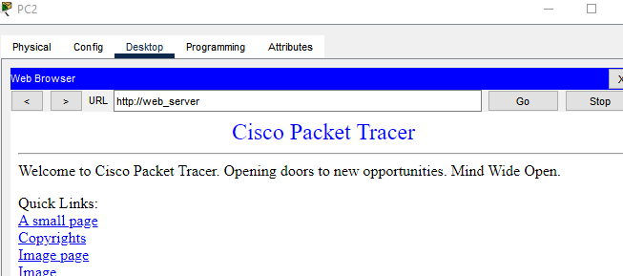

**Experiment 1**

**i).**

**Topology**

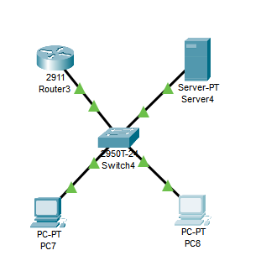

**Router**

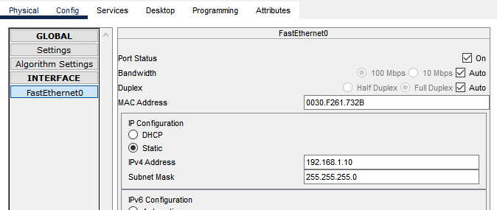

**Server**



